- Title and Author.
Assignment 6
110704008 羅瑋翔
xianglo9121.mg10@nycu.edu.tw
- Statement of the Problem.
In this assignment, we are going to implement an efficient method to find the maximum elements of the sequence which the elements lie on the interval [l, r], l and r are the left index and the right index of the elements, respectively. And the users will be asked to input n queries (n is a large number). I used two methods to solve this problem and compare their time used of CPU time. One is the straight method which we often used (Suppose the first one is the maximum and compare the other elements if it is replace the first one with it and compare the others). The other is the segment tree method. The main idea of this method likes binary tree. Separating the tree into two subtrees again and again (the index of the subtrees lies on [l, r]). Since the two subtrees only contain one node. Comparing the value and send the bigger one to their parent node until reaching the root of the tree. Hence, we will have the maximum of the sequence. The time complexity is O (log n + k “k is the number of queries”) while the first method is O (n). So, when we are finding sequence with lots of elements and lots of numbers of queries. It might be great with using the second method, in theory.
- Main Results.
- There are three libraries iostream, iomanip and ctime. The second one is included for fixing the precision of the CPU time that the two methods used. And the last one is included for using the data type clock_t to calculate the CPU time that been used of the two methods. The two functions representing the two methods of finding the maximum on the interval of the sequence. And the main idea of the method I have mentioned in the second part of this assignment. In the main function, I enable the users to input the number of elements (eleNum) and the numbers of the queries (qNum). With the value of eleNum, I can allocate memory to the array which used to store the sequence, and the value of qNum, I can allocate memory to the array which used to store the pairs (the first elements is the left index, and the second index is the right index). With this information, then call the two functions to find the maximum of the sequence and calculate the CPU time used on finding the maximum. Last, print the time used of the two functions to compare the efficiency. And print the maximum found by the two functions to check if the algorithm is right.
- Array is the only data structure I used in this assignment. I think it is unnecessary to create a struct to save the left and right indices if I need to use the value of left index and right index. I used an array to store the elements in the sequence and an array to store the pairs of left index and right index, which is used to finding the maximum on the interval.
- Program with comments.
#include <iostream>
#include <ctime>//this library is used to calculate the CPU time
#include <iomanip>//this library is used to set the precision of the CPU time
using namespace std;

void straight(int* ele, pair<int, int>& query);//the function uses the straight method to find the maximum

int segmentQuery(int* arr, int l, int r, int L, int R);//this function uses the segment tree method to find the maximum

int main(){
int eleNum = 0, qNum = 0;
clock_t start_1, end_1, start_2, end_2;
double time_1, time_2;

cout << "Enter the number of the element : ";
cin >> eleNum;
int* ele = new int[eleNum];//reallocate memory for the array (save the input element as X0, x1, ..., Xi) which has unknown size

for(int i = 0; i < eleNum; i++)
cin >> ele[i];

cout << "Enter the number of the queries : ";
cin >> qNum;

pair<int, int>* query = new pair<int, int>[qNum];//reallocate memory for the array (save the query of an interval) which has unknown size
for(int i = 0; i < qNum; i++){
cin >> query[i].first >> query[i].second;
}
cout << "The result of the straight method : " << endl;
start_1 = clock();
for(int i = 0; i < qNum; i++){
//if the input index is valid, find the maximum between the interval through the straight method
if(query[i].first >= 0 && query[i].second < eleNum && query[i].first <= query[i].second)
straight(ele, query[i]);
//if the input index is invalid, print the error message
else
cout << "The " << i + 1 << " query has the wrong index value." << endl;
}
end_1 = clock();

cout << "\nThe result of the segment tree method : " << endl;
start_2 = clock();
for(int i = 0; i < qNum; i++){
//if the input index is valid, find the maximum between the interval through the segment tree method
if(query[i].first >= 0 && query[i].second < eleNum && query[i].first <= query[i].second)
cout << "The maximum element between index "<< query[i].first << " and " << query[i].second << " is " << segmentQuery(ele, query[i].first, query[i].second, 0, eleNum - 1) << endl;
//if the input index is invalid, print the error message
else
cout << "The " << i + 1 << " query has the wrong index value." << endl;
}
end_2 = clock();

time_1 = (double)(end_1 - start_1) / CLOCKS_PER_SEC;
time_2 = (double)(end_2 - start_2) / CLOCKS_PER_SEC;
//print the CPU time of two methods to compare the efficiency
cout << "\nThe CPU time of the straight method used is : " << fixed << setprecision(10) << time_1 << endl;
cout << "The CPU time of the segment tree method used is : " << fixed << setprecision(10) << time_2 << endl;
delete[] ele;
delete[] query;

return 0;
}

void straight(int* ele, pair<int, int>& query){
int ind = query.first;
for(int i = query.first; i <= query.second; i++){
if(ele[ind] < ele[i])
ind = i;
}
cout << "The maximum element between index "<< query.first << " and " << query.second << " is " << ele[ind] << "." << endl;
}

int segmentQuery(int* arr, int l, int r, int L, int R){
if(L == R)
return arr[L];
int m = (L + R) / 2;
if(r <= m)
return segmentQuery(arr, l, r, L, m);//find the part of the left subtree
else if(l > m)
return segmentQuery(arr, l, r, m + 1, R);//find the part of the right subtree
else{
//compare the maximum of the left subtree and the maximum of the right subtree, then return the bigger one
if(segmentQuery(arr, l, r, L, m) > segmentQuery(arr, l, r, m + 1, R))
return segmentQuery(arr, l, r, L, m);
else
return segmentQuery(arr, l, r, m + 1, R);
}
}

- Outputs.
- With 10000 random numbers. And 100 queries.
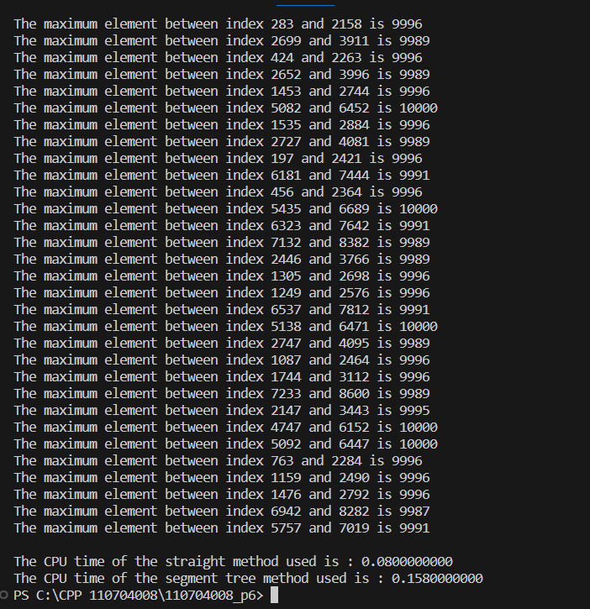
- With 50000 random numbers. And 100 queries
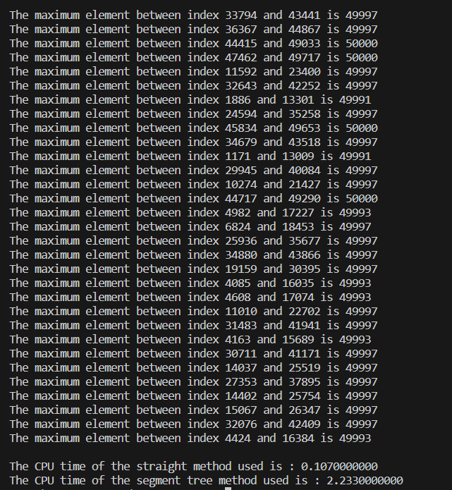
- With 100000 random numbers. And 100 queries.
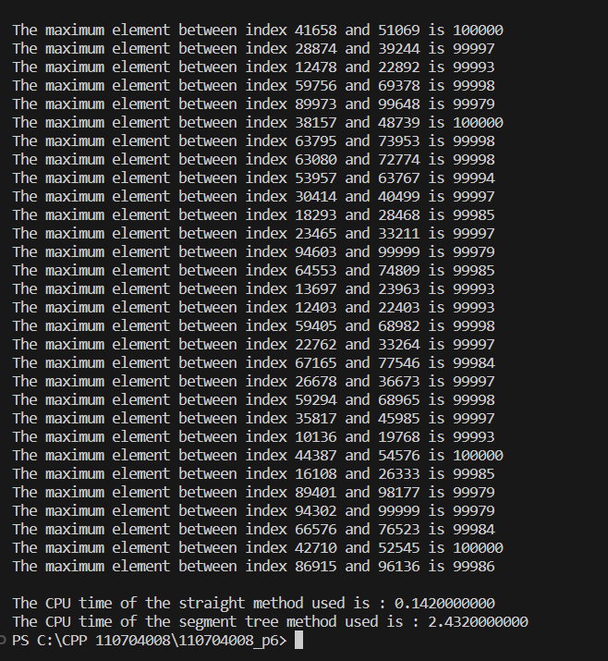
- With 10^6 random numbers. And 100 queries.
We cannot randomly generate 1000000 numbers. Since, we do not have a memory to store the sequence.
- Conclusions.
In theory, finding the maximum on the interval [l, r] of the sequence with the segment tree method would be better and more efficient if there are a lot of elements lies on the interval and the number of the queries is much. But the output is contradiction to theory. The reason might be (1) memory access problem. Since the segment tree relies on tree structures and might involve discontinuous memory access patterns. In contrast, the straight method may benefit from better cache locality and result in faster access times, especially for large sequences. (2) Compiler optimization. Some algorithms more form certain code, Hence, these results occur. (I know this on the class thorough the professor) This interested me a lot, since I do not want just to know the things in theory, I want to know more that is closed to reality. There is an interesting thing, the fourth input data cannot be implemented since the memory allocate is not large enough to store the array with 1 million elements. There are a couple of methods to solve this problem. Such as reducing the usage of the memory while the program is running, reduce data load to minimize the amount of data the program needs to process or access, in theory. Hope that in the future, professor can reference more about this. This assignment is quite easy if we do not do too much additional functions or save the memory, but quite important if we want to reduce the time complexity while searching something in the sequence such as target, maximum, or updating the elements and so forth.

